P8.7

Program Design

## Input

1. In detail indicate what the inputs to this program are?

5 numbers long zipcode and 32 characters long barcode and some digits to make choice

1. How do you validate the input

Initialize two string variables and one int character

1. Pseudocode: Briefly explain how this section will look like

## Processing

1. What is this program calculating?

Converting some int digits to a string variable and output it to the screen

1. Can we divide the calculations to the smaller “modules”

No. I do believe I made it very detailed.

1. Pseudocode: Briefly explain how this section will look like – Each module should have its own section.

## Output

1. What will this program display to the users?

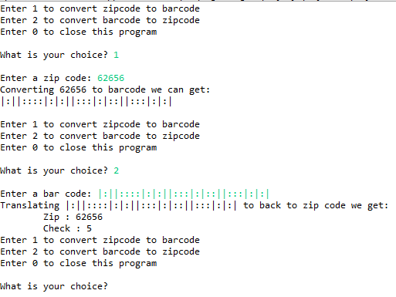

1. What kind of formatting this output will use (Currency with $ …)?

String formatting and digits formatting

1. Pseudocode: Briefly explain how this section will look like

## Library

What Libraries do you need for this program?

**import** java.util.Scanner;

## Initialization and constant variables

1. What variables need to be initialized?

String bars

**int** sum

String zip

**int** weight7 ;

**int** weight4 ;

**int** weight2 ;

**int** weight1 ;

**int** weight0 ;

Scanner zb

String zip,bars;

**int** ch

1. What variables need to be defined as constant

String bars="|";

String*weight*[]={"||:::",":::||","::|:|","::||:",":|::|",":|:|:",":||::","|:::|","|::|:","|:|::"};